Trinity International College

Kathmandu, Nepal



**Assignment-I**

**(CFA)**

Submitted By: Submitted To:

Mohan Thapa Susan Sunuwar

Symbol No. BCA79110

BCA 1st Semester

Submission Date:17th Jestha, 2080

**Assignment 1**

1. **Prepare a report on internal and external DOS commands.**

**Answer:**

**Internal Dos command**

* **Cd**

Displays the name of the current directory or changes the current directory.

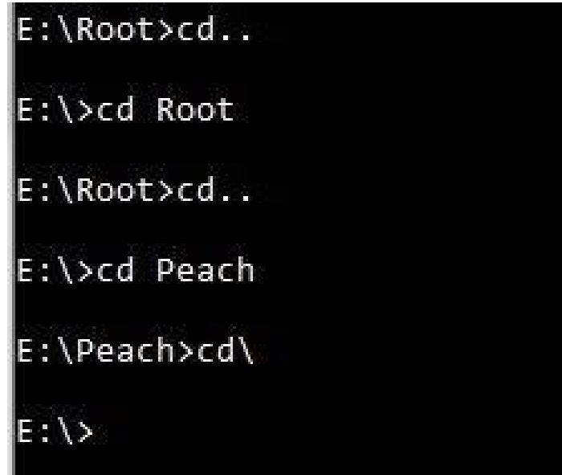

* **Copy**

Copies one or more files from one location to another.

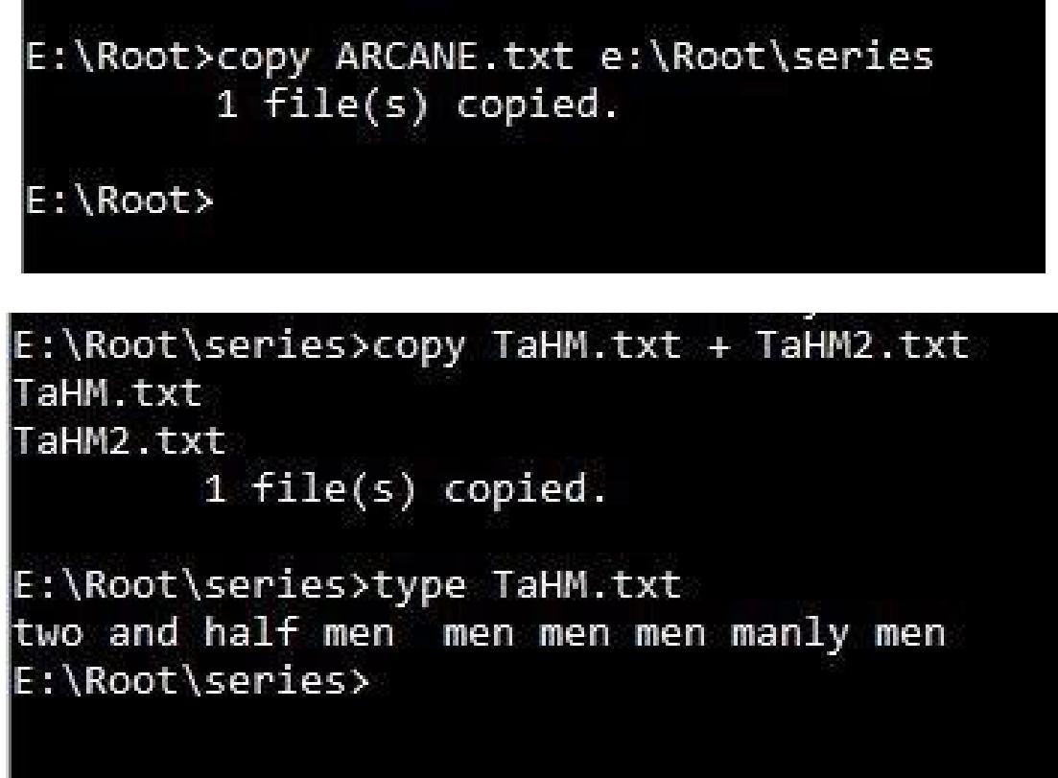

* **Copy con**

It allows the creation of file.

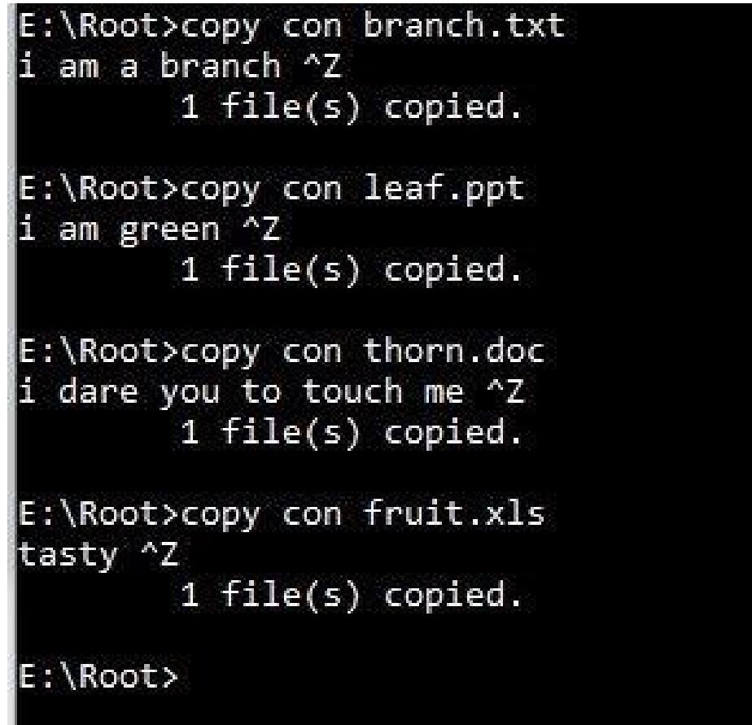

* **Date**

Displays or sets the system date. If used without parameters, date displays the current system date setting and prompts you to enter a new date.

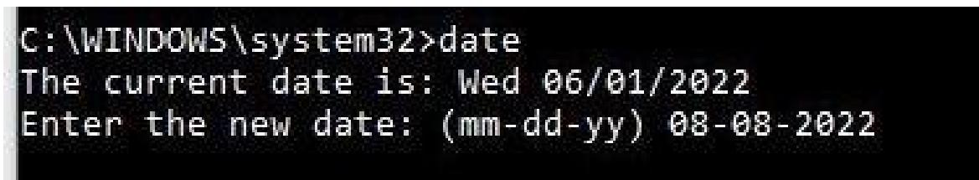

• **Del**

Deletes one or more files.

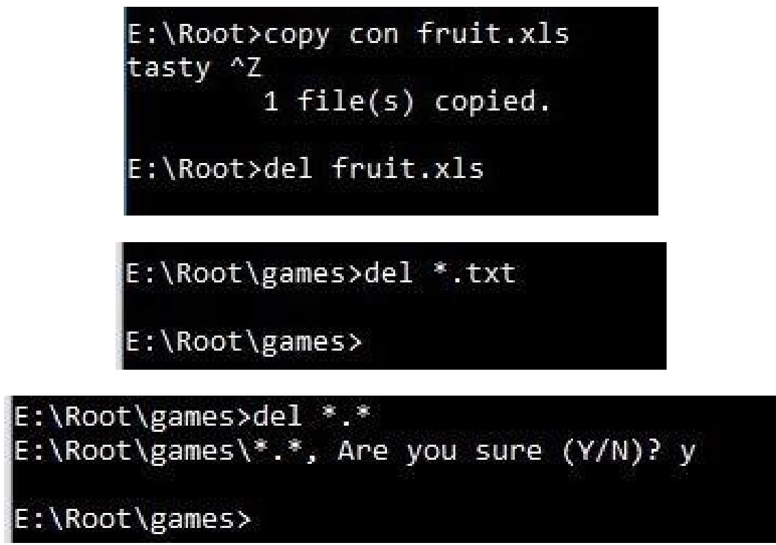

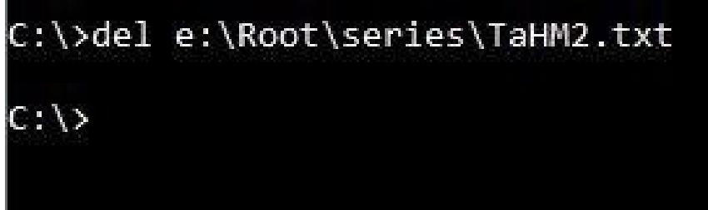

* **Dir**

Displays a list of a directory's files and subdirectories.

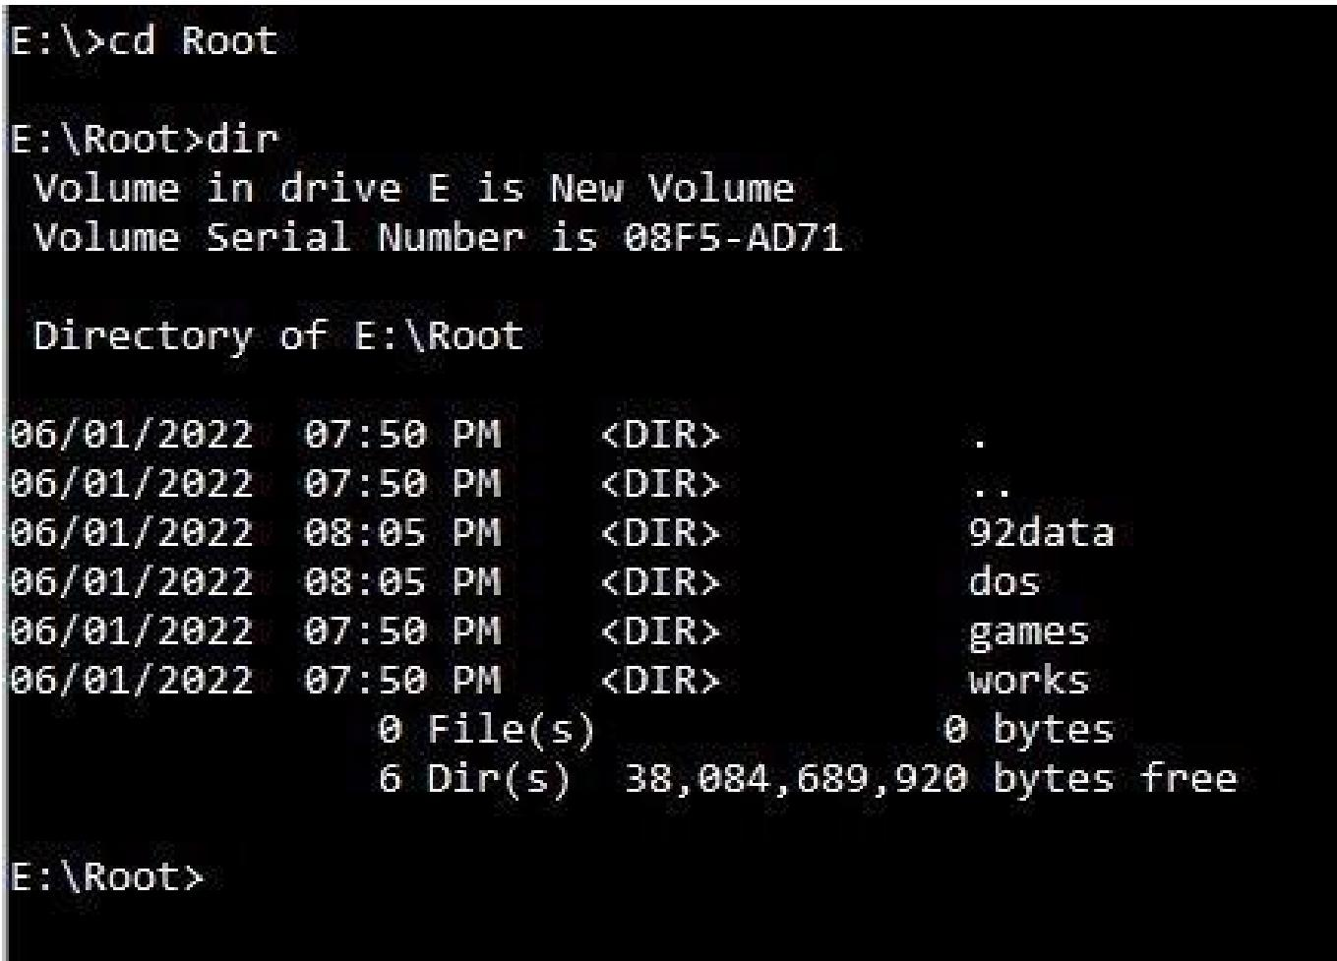

* **Md / Mkdir**

Creates a directory or subdirectory.

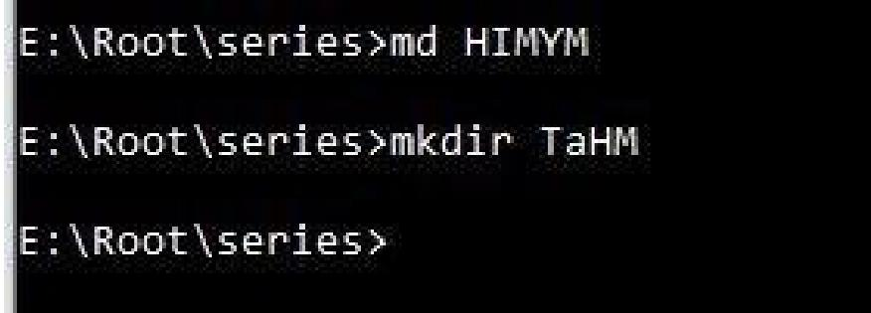

* **Move**

Moves one or more files from one directory to another directory.

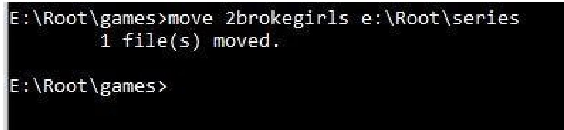

* **Net user**

Net User is a command line tool that allows system administrators to manage user accounts on Windows PCs.

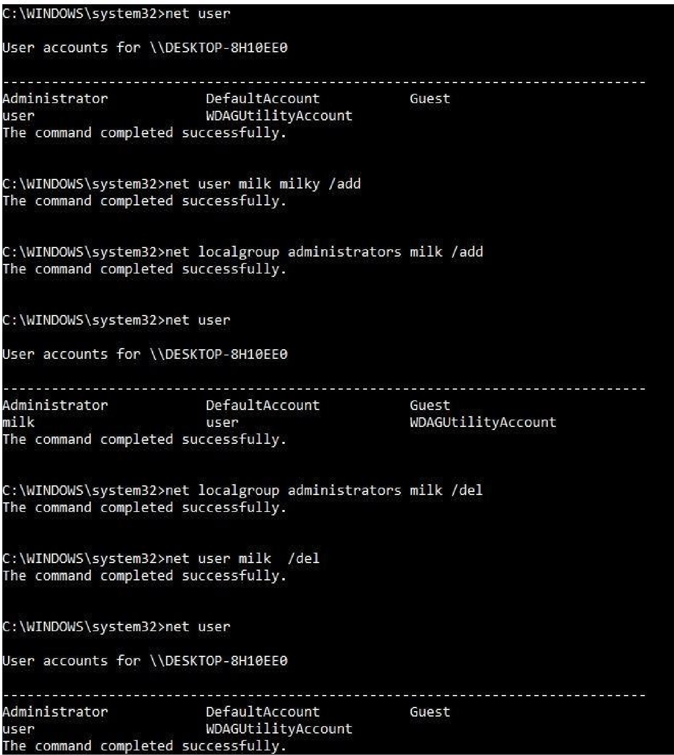

• **Notepad**

Notepad is used to edit the file.

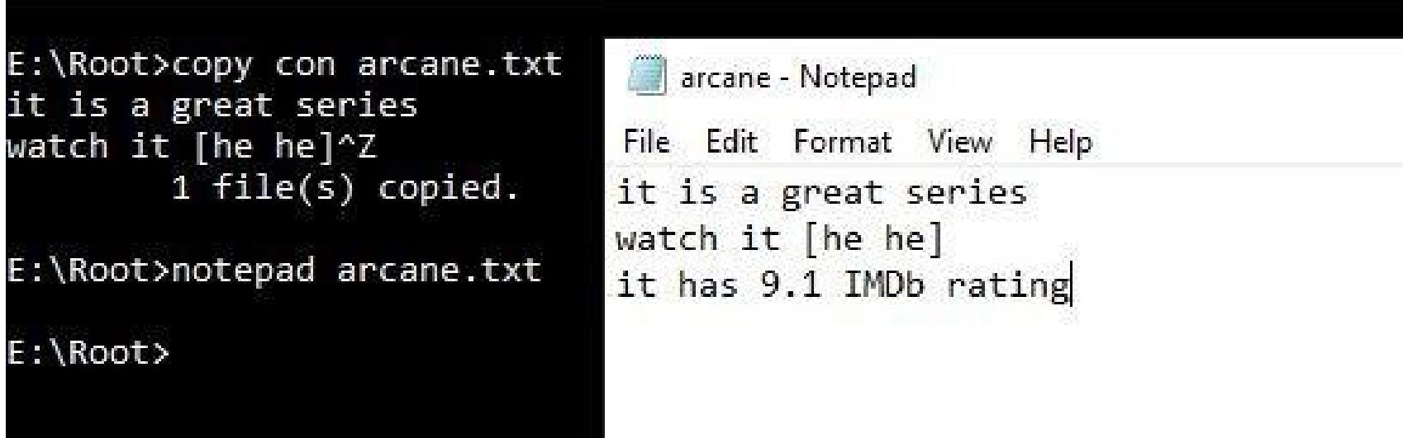

* **Rd / Rmdir** Rmdir (or rd) is a command which will remove a directory or a folder.

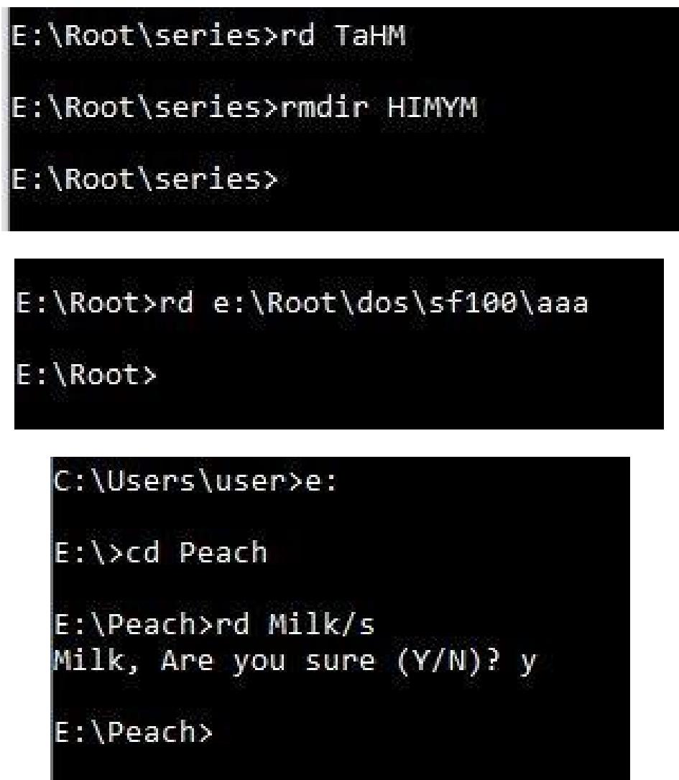

* **Ren**

Renames files of directories.

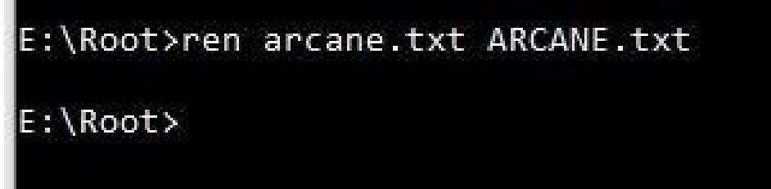

* **Time**

Displays or sets the system time.

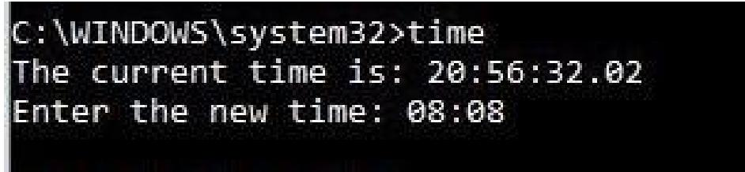

* **Type:** Type displays the contents of a text file.

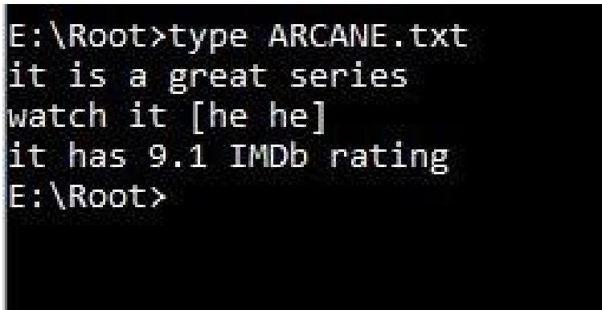

**External DOS commands**

* **Attrib**

Attrib is use to hide or show the files.

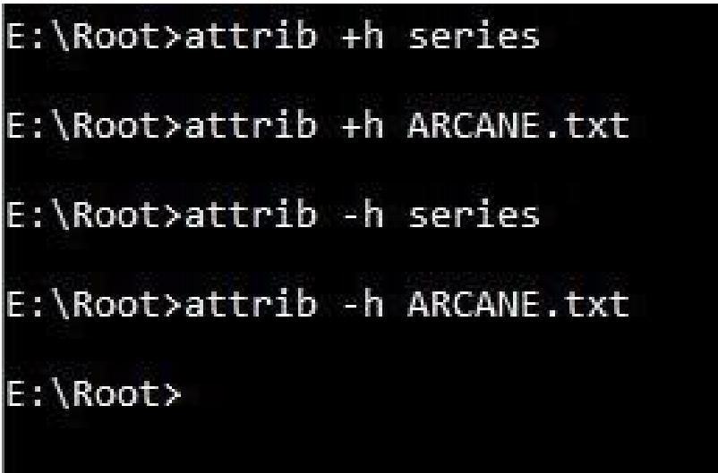

* **Chkdsk**

Chkdsk is used to check the disk.

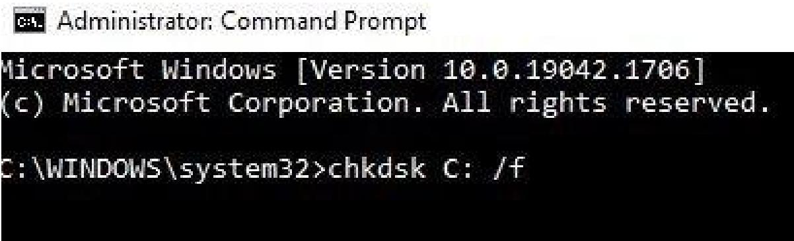

* **Fc**

Fc is used to compare two files.

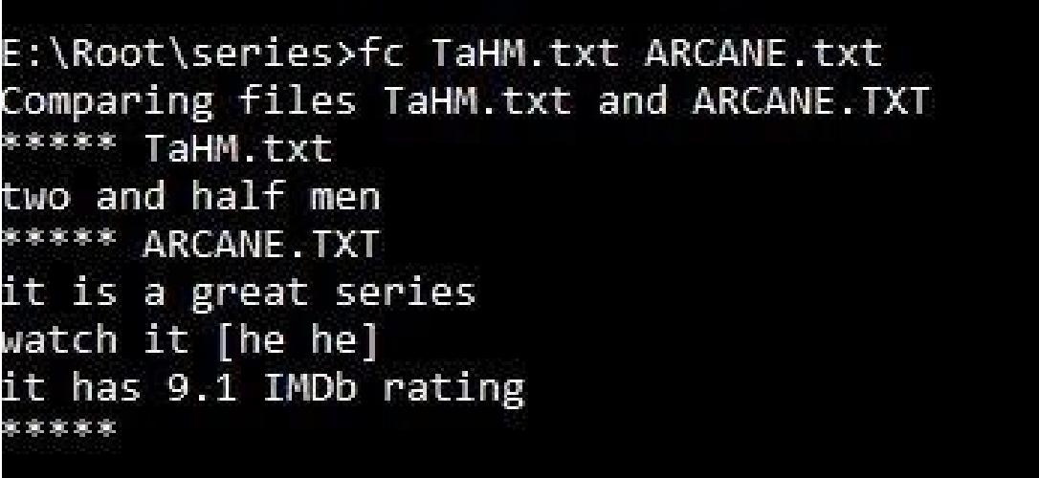

* **Find**

Find is used to find a string n a file.

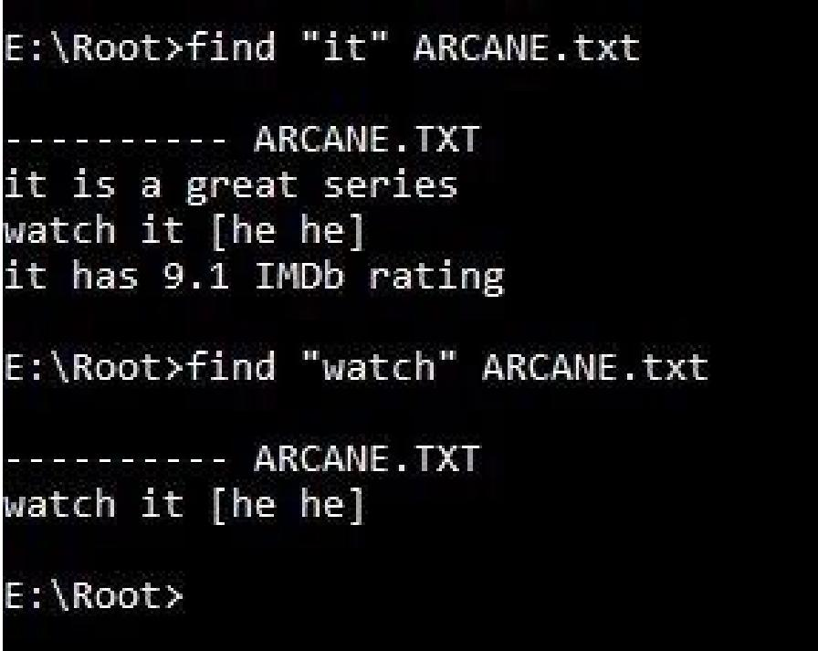

* **Label**

Label creates, changes, or deletes the name of a disk.

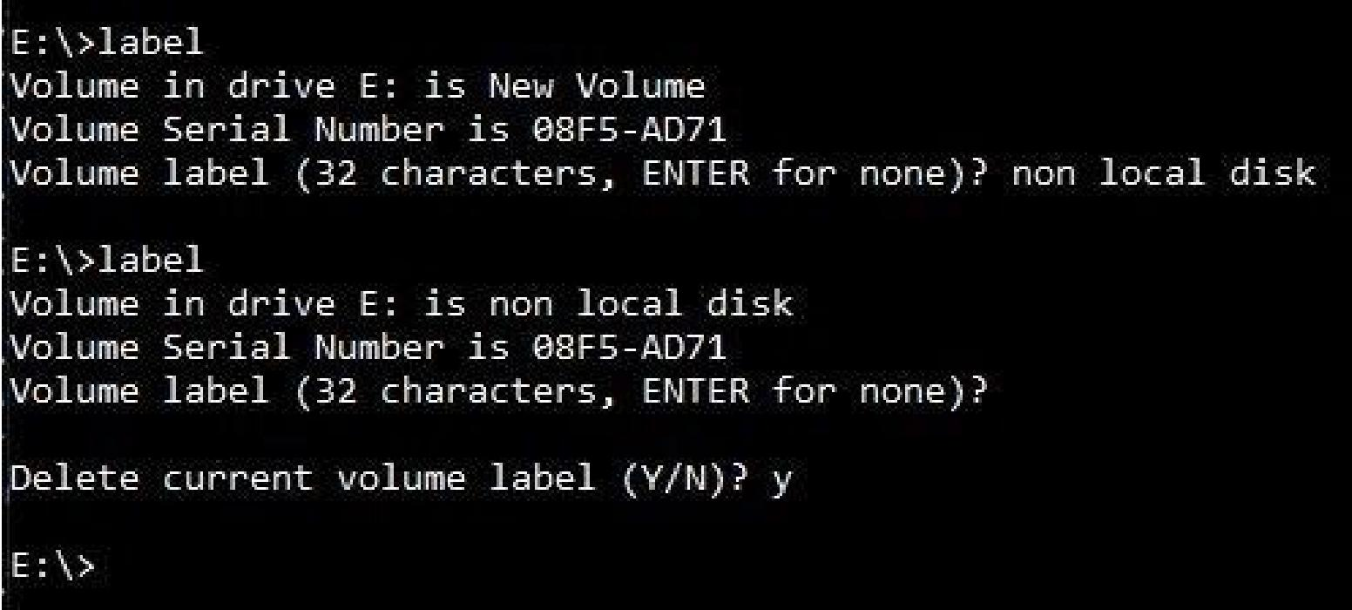

* **Sort**

Sort is used to show the content of the file in ascending of descending order.

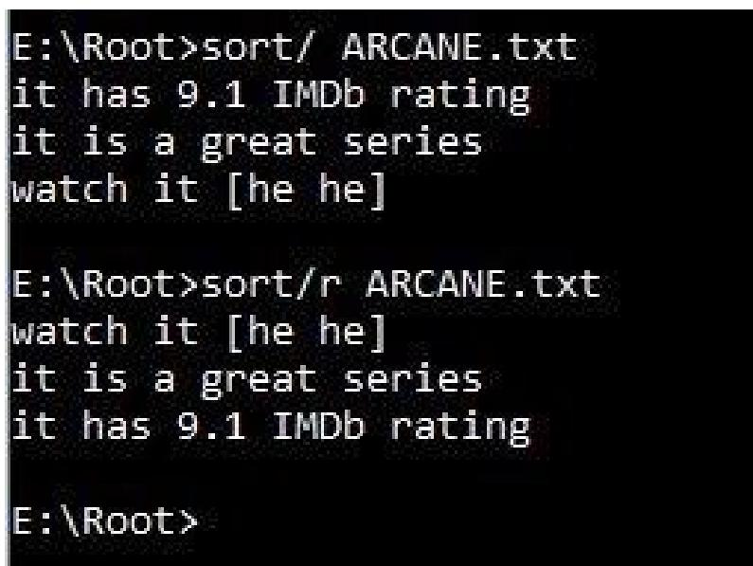

* **Tree**

Tree displays the directory/folder structure of a path or of the disk in a drive graphically.

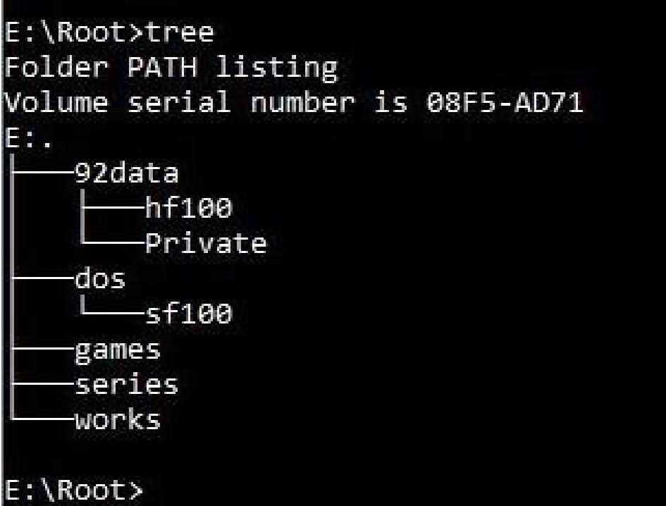

• **Xcopy**

Copies files and directories, including subdirectories.

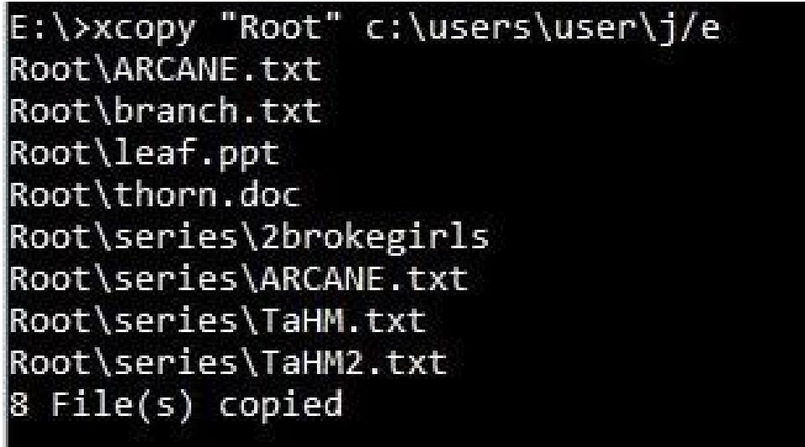

2. **Write a batch program that creates the following directory structure.**

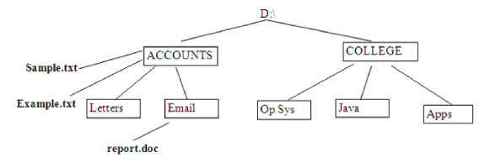

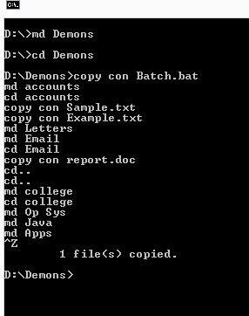

1. **Create a directory structure as given in the diagram below (root can be any directory or disk drive) and show the tree structure using “tree” command.**

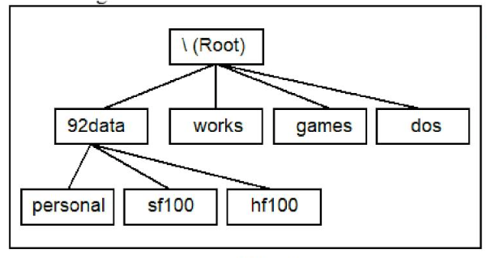

**Answer**

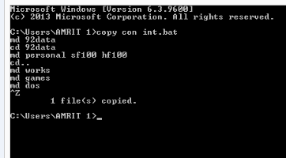

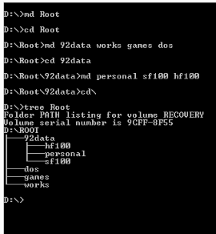

1. **Show all files having extension “.txt” of D: local drive.**

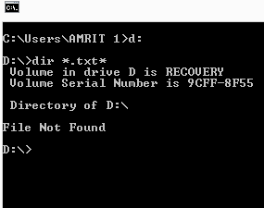

1. **Rename the directory “personal” to “Private” from question no. 3.**

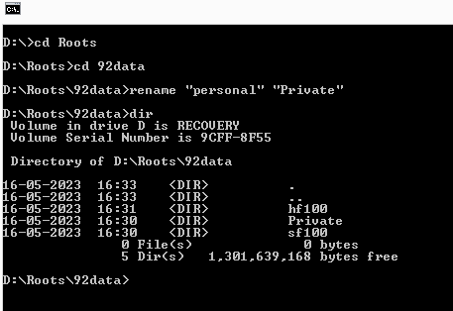

1. **Change the date and time from of the system to “2022-08-08” and “08:08”.**

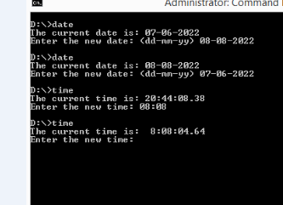

1. **Move the directory “hf100” from 92data directory to dos.**

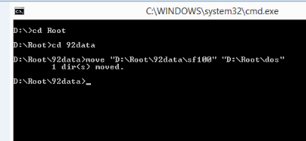

1. **Copy the “Example.txt” file from Accounts directory to college -> Apps.**

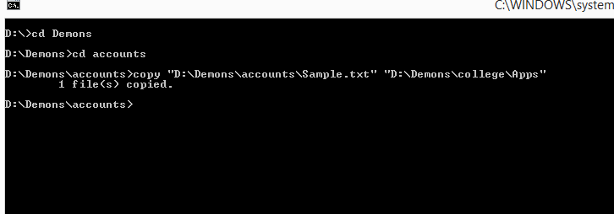

1. **Display all the hidden files of drive C: drive.**

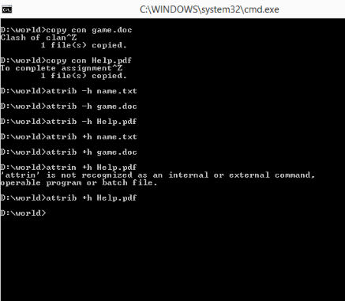

1. **Create a file named “File1”.**

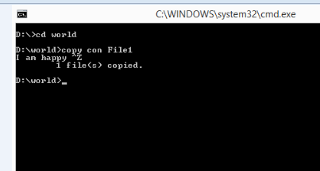

1. **Edit the file “File1” and insert the new line “This is a new file”.**

